Our Ref: _______________ Your Ref: ________________________ Date: __________________

Baptist Church

Baale Yaku Site Area, P. O. Box 644,

Ogbomoso, Oyo State. Tel. 07052425407

Email: [newsprinbaptistchurch@gmail.com](mailto:newsprinbaptistchurch@gmail.com)

Website: newspringbc.comze.com

NEW SPRING

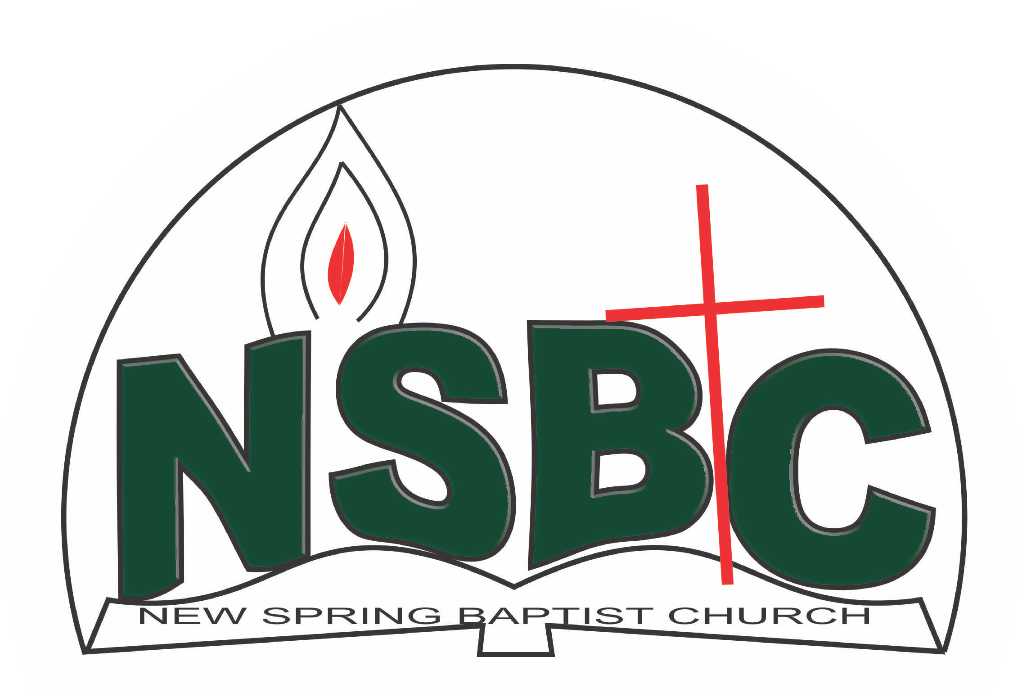

December 27, 2021

Dear Mrs. Mobolape Adelakun,

Nomination to Serve as an Officer and Worker in the Church in 2022.

Calvary greetings in the precious name of our Lord and Saviour Jesus Christ. It is our pleasure to inform you that, at the Church-in-Conference held on December 19, 2021 the Church ratified your nomination to serve in the following areas between January 1 and December 31,2021:

1. Chairman, Hospitality Committee
2. Chairman, Personnel Committee
3. Secretary, Women’s Missionary Union (WMU)
4. Member, Sanctuary Care Committee under the chairmanship of Mrs. Funmi Adetutu
5. Member, Church Council

Please refer to the table below for the key functions of each of these roles. Details can be found in the Church constitution. You are strongly encouraged to become familiar with the tasks as stated in the document. There will be an orientation of the Church workers on January 15, 2022 at 8:30 a.m. on the church premises. Please ensure you participate in this training.

“Now it is required that those who have been given a trust must prove faithful. I Corinthians 4:2”. May God find you faithful in the task He has assigned to you.

| Domain | Key function of Office, Department or Committee |
| --- | --- |
| Secretary, WMU | To prepare women, young ladies/girls and children for mission |
| Chairman, Hospitality Committee | Responsible for organizing social activities of the Church |
| Sanctuary Care Committee | To ensure the auditorium is kept clean and suitable for worship service |
| Chairman, Personnel Committee | To assist the Church in matters relating to personnel administration |
| Church Council member | The Church Council is the governing body of the Church whose membership, under the leadership of the Holy Spirit, holds one another mutually accountable with respect and love and sees to the smooth running of the Church. |

Thank you for accepting to serve in this Church.

Yours in His service

Olusayo Okediji Blessed Agboola

Church Secretary Chairman, Nominating Committee